TOPS TECHNOLOGY

**Training | Outsourcing | Placement | Study Abroad**

**Software Engineering**

**Assignment**

**Module:- 1**

**SE – Overview of IT Industry**

**1)Explain in your own words what a program is and how it functions.**

**🡪**A program is a set of instructions written in a programming language that tells a computer what to do. It functions by executing these instructions step by step to perform a specific task, such as calculating numbers, displaying text, or managing data.

When a program runs, the computer's processor follows the instructions, interacts with memory and storage, and produces the desired output. Programs can be simple (like a calculator) or complex (like a web browser), and they help automate tasks, solve problems, and enhance efficiency in various fields

**2) Explain in your own words what a program is and how it functions. What is Programming?**

Ans:- A computer program is nothing but a set of instructions (smallest unit of execution) that are used to execute particular tasks to get particular results.

**What are Functions in Programming**

**-🡪**Functions in Programming is a block of code that encapsulates a specific task or related group of tasks.

**3)** **What are the key steps involved in the programming process?**

**🡪**Problem Definition – Understand and define the problem clearly.

Planning & Algorithm Design – Outline the logic and structure using flowcharts or pseudocode.

Coding – Write the actual program using a programming language.

Compilation & Execution – Convert the code into machine language and run it.

Testing & Debugging – Identify and fix errors through testing.

Documentation – Record details for future reference and maintenance.

Maintenance & Updates – Modify and improve the program as needed.

**4)** **What are the main differences between high-level and low-level programming languages?**

|  |  |
| --- | --- |
| high-level | low-level |
| 1) high-level s less memory efficient. | 1) low-level is high memory efficient |
| 2) It is easy to understand. | 2) It is tough to understand. |
| 3) Debugging is easy. | 3) Debugging is complex comparatively. |
| 4) It is simple to maintain. | 4) It is complex to maintain comparatively. |
| 5) It is portable. | 5)It is non-portable. |
| 6) It can run on any platform. | 6) It is machine-dependent. |
| 7)It needs compiler or interpreter for translation. | 7) It needs assembler for translation. |
| 8) It is used widely for programming. | 8) It is not commonly used now-a-days in programming. |
| 9) Java,Python,c++ | 9) Assembler language |

**4)** **Describe the roles of the client and server in web communication.**

**LAB EXERCISE: Research and create a diagram of how data is transmitted rom a client to a server over the internet.**

**🡪** Web communication follows the client-server model, where both the client and server play specific roles in exchanging information over a network.

**Client Role**:

The client is typically a web browser, mobile app, or software that requests resources or services from the server.

- Sends HTTP/HTTPS requests to the server.

- Displays web pages or application data received from the server.

- Can include **caching mechanisms** to store data for faster access.

- May run client-side scripts for dynamic content.

**Server Role:**

The server is a powerful computer or cloud service that listens for client requests and responds accordingly.

* Processes incoming HTTP/HTTPS requests.
* Fetches or manipulates data from a database.
* Runs server-side scripts (e.g., PHP, Node.js, Python, etc.).
* Sends HTML, CSS, JavaScript, or JSON responses back to the client.
* Implements security measures .

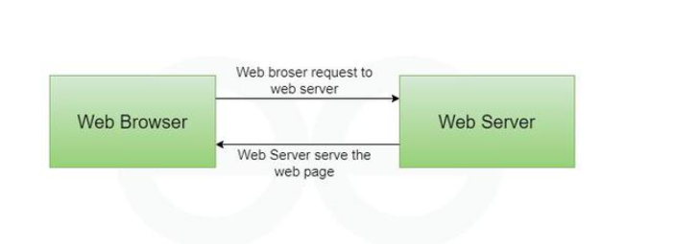

5) Explain the function of the TCP/IP model and its layers.

**LAB EXERCISE: Design a simple HTTP client-server communication in any language.**

**🡪**

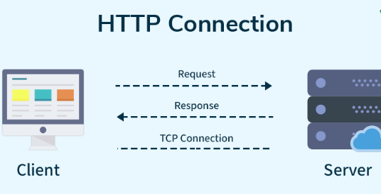

1) **Client Role**

* The client sends a request to the server (e.g., opening a webpage).
* It waits for the server’s response.
* Once the response arrives, the client processes and displays the data.

**2) Server Role**

* The server listens for requests from the client.
* It processes the request (e.g., fetching data from a database).
* Then, it sends a response back to the client.

**Example of Communication**

1. The client requests a webpage by entering www.example.com in a browser.
2. The server receives the request and retrieves the webpage.
3. The server sends the webpage data back to the client.

4.The client displays the webpage to the user.

**🡪** The TCP/IP (Transmission Control Protocol/Internet Protocol) model is a set of rules that allows computers and devices to communicate over the internet. It ensures that data is transmitted, routed, and received correctly across networks.

**Layers of the TCP/IP Model**

**1. Application Layer**

* Handles communication between applications (e.g., web browsers, email).
* Uses protocols like HTTP, HTTPS, FTP, SMTP, DNS.
* Example: A web browser requests a webpage using HTTP.

**2. Transport Layer**

* Ensures reliable data delivery between devices.
* Uses two main protocols:
  + TCP (Transmission Control Protocol): Reliable, ordered, and error-checked delivery (e.g., web pages, emails).
  + UDP (User Datagram Protocol): Faster but unreliable (e.g., live streaming, online gaming).

**3. Internet Layer**

* Manages routing of data across networks.
* Uses IP (Internet Protocol) to assign addresses to devices.
* Ensures data packets reach the correct destination.

**4. Network Access Layer (Link Layer)**

* Handles physical network connections (e.g., Wi-Fi, Ethernet).
* Converts data into signals (electrical, radio, etc.) for transmission.

6) **Explain Client Server Communication?**

🡪 **Client-Server Communication**

Client-server communication is the exchange of data between a client (user device) and a server (central computer) over a network. The client **requests** services, and the server **responds** by providing the required data or services.

**How It Works**

1. **Client Sends a Request** – A user enters a website URL in a browser.
2. **Server Processes the Request** – The server retrieves or processes the required data.
3. **Server Sends a Response** – The server sends the webpage or data back to the client.
4. **Client Displays the Data** – The browser loads and displays the webpage.

**Examples of Client-Server Communication**

* A web browser accessing a website.
* A mobile app retrieving data from an online database.
* A video streaming service providing content on demand.

**7) How does broadband differ from fiber-optic internet?**

**LAB EXERCISE: Research different types of internet connections (e.g., broadband, fiber, satellite)and list their pros and cons.**

🡪 Broadband (DSL/Cable) Protocols: Uses PPPoE (Point-to-Point Protocol over Ethernet) for DSL and DOCSIS (Data Over Cable Service Interface Specification) for cable internet.

Fiber-Optic Protocols: Uses GPON (Gigabit Passive Optical Network) and EPON (Ethernet Passive Optical Network) for data transmission.

Key Difference: Broadband transmits data using electrical signals over copper cables, while fiber-optic internet uses light signals through fiber-optic cables, making it faster and more reliable.

LAB EXERCISE: Research different types of internet connections (e.g., broadband, fiber, satellite)and list their pros and cons.

🡪 **Broadband (DSL/Cable)**

Widely available, affordable

Slower than fiber, speed varies

**Fiber-Optic**

Very fast, reliable, low latency

Expensive, limited coverage

**Satellite**

Works in remote areas, no cables

High latency, weather issues

**Mobile (3G/4G/5G)**

Wireless, portable, fast (5G)

Data limits, signal-dependent

**Fixed Wireless**

No cables, good for rural areas

Affected by weather, slower than fiber

**8) What are the differences between HTTP and HTTPS protocols?**

**LAB EXERCISE: Simulate HTTP and FTP requests using command line tools (e.g., curl).**

**🡪1. HTTP Requests (Web Communication)**

* Used to access websites and APIs.
* A browser usually makes these requests when you visit a webpage.
* You can send requests to get, send, or update data.

Example:

* A request is sent to a website to load a page.
* The server processes the request and sends back the webpage.

**2. FTP Requests (File Transfer Protocol)**

* Used to upload and download files from a remote server.
* Commonly used for website hosting and backups.

Example:

* You request to download a file from a server.
* The server sends the file to your computer.

|  |  |
| --- | --- |
| **HTTP** | **HTTPS** |
| HTTP stands for HyperText Transfer Protocol. | HTTPS for HyperText Transfer Protocol Secure. |
| HTTP, URL begins with “http://”. | HTTPs, URL starts with “https://”. |
| HTTP uses port number 80 for communication. | HTTPs uses 443 port number for communication. |
| HTTP is considered to be unsecure. | HTTPs is considered as secure. |
| HTTP works at Application Layer. | HTTPS works at Transport Layer. |
| HTTP faster than HTTPS | HTTPS slower than HTTP |
| Search engines do not favour the insecure website. | Improved reputation of the website in search engine. |

**9) What is the role of encryption in securing applications?**

**LAB EXERCISE: Identify and explain three common application security vulnerabilities. Suggest possible solutions.**

**🡪**Encryption plays a critical role in securing applications by transforming sensitive data into an unreadable format, accessible only to authorized users with the decryption key.

**Software Applications and Its Types:** Software applications are programs designed to perform specific tasks for users.

**1. System Software**

* Manages hardware and system resources.
* Examples: Operating systems like Windows, macOS, and Linux.

**2. Application Software**

* Designed for end-users to perform specific tasks.
* Examples: Microsoft Word (word processing), Excel and web browsers.

3. **Development Software**

Provides tools for software developers to create applications.

Examples: IDEs like Visual Studio, PyCharm, and compilers.

4. **Middleware**

* Connects different software applications or systems to enable communication.
* Examples: Database management systems (DBMS), APIs, and message brokers.

**10) What is the difference between system software and application software?**

**LAB EXERCISE:Identify and classify 5 applications you use daily as either system software orapplication software.**

**🡪**

|  |  |  |
| --- | --- | --- |
| **Application** | **Type** | **Reason** |
| Android OS | System Software | Manages hardware resources and supports other apps. |
| Google Maps | Application Software | |  | | --- | |  |  |  | | --- | | Provides navigation and location services. | |
| WhatsApp | Application Software | Used for messaging, calls, and media sharing. |
| Task Manager | System Software | Monitors and controls system performance and processes. |
| YouTube | Application Software | |  | | --- | |  |  |  | | --- | | Streams videos and content for entertainment and learning. | |

**--------------------------------------------------------------------------------------------------------------------------**

|  |  |
| --- | --- |
| **System Software** | **Application Software** |
| System Software maintains the system resources and gives the path for application software to run. | Application software is built for specific tasks. |
| Low-level languages are used to write the system software. | While high-level languages are used to write the application software. |
| Example: System software is an operating system, etc. | Example: Application software is Photoshop |
| System Software programming is more complex than application software. | Application software programming is simpler in comparison to system software. |
| System software runs independently. | Application software is dependent on system software because they need a set platform for its functioning. |

**11)** What is the significance of modularity in software architecture?

**🡪** Maintainability – Easy updates and fixes.

Reusability – Use modules in different projects.

Scalability – Add new features easily.

Debugging – Isolate and fix errors faster.

Collaboration – Teams work independently.

Flexibility – Modify modules with minimal impact.

Performance – Optimized modules improve efficiency.

Faster Development – Reuse saves coding time.

**LAB EXERCISE: Design a basic three-tier software architecture diagram for a web application.**

The Three-Tier Client-Server Architecture divides systems into presentation, application, and data layers, increasing scalability, maintainability, and efficiency.

**Architecture design model:**

* **Presentation Tier:** The user interface layer, where interactions occur. It handles data display and user input.
* **Application Tier**:The business logic layer, which processes user requests, performs computations, and makes decisions. It acts as a mediator between the presentation and data tiers.

**Data Tier**:The storage layer, is responsible for managing and storing data. It handles database operations and data retrieval

**three-tier software architecture**

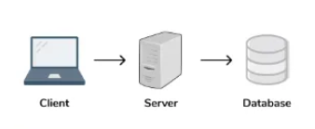

**12)** Why are layers important in software architecture?

**🡪** Separation of Concerns: Each layer handles a specific responsibility, improving code organization.  
Scalability: Easier to modify or expand individual layers without affecting the entire system.  
Maintainability: Clear structure simplifies debugging, testing, and future updates.  
Reusability: Common logic (e.g., authentication, logging) can be reused across multiple applications.  
Flexibility: New technologies or features can be integrated with minimal disruption

**13) Explain the importance of a development environment in software production.**

**LAB EXERCISE: Explore different types of software environments (development, testing, production).Set up a basic environment in a virtual machine.**

🡪 **Error Detection:** Early identification of syntax, logic, and runtime errors prevents issues from progressing.

Version Control: Enables tracking of code changes and collaborative development.  
Dependency Management: Ensures all required libraries, frameworks, and tools are correctly configured.

Automated Testing: Developers can run unit tests frequently to validate functionality.  
Customization: Allows developers to configure environments to match production settings closely.  
 Debugging Support: Tools like breakpoints, watch variables, and stack traces help resolve issues faster.  
Safe Experimentation: New features can be explored without risking stability.  
Efficient Collaboration: Teams can work on different features independently and merge their changes smoothly.

**Types of Software Environments**

1. Development Environment – Used for coding and initial testing.
2. Testing Environment – Runs tests to find bugs before deployment.
3. Production Environment – Live system used by end-users.

**Setting Up a Basic Environment in a Virtual Machine**

1. Install Virtual Machine Software (e.g., VirtualBox, VMware).
2. Create a New VM and select the OS.
3. Allocate CPU, RAM, and Storage.
4. Install the OS (Linux/Windows).
5. Set up Development Tools (e.g., IDEs, databases, servers).
6. Configure Networking & Security settings.
7. Test the environment to ensure proper functionality.

**14) What is the difference between source code and machine code?**

**LAB EXERCISE: Write and upload your firstsource code file to Github.**

|  |  |
| --- | --- |
| **Source Code** | **Machine Code** |
| Human-readable instructions written in programming languages (e.g., Python, Java). | Binary instructions (0s and 1s) that a computer's CPU can directly execute. |
| Easily understandable by developers. | Difficult for humans to read or interpret. |
| Written using text-based syntax (e.g., if, for, print). | Consists of binary code or hexadecimal values. |
| Requires compilation or interpretation to become executable. | Directly executed by the computer's hardware. |
| print("Hello World") in Python. | 10110000 01100001 (Binary equivalent of machine instructions). |

**LAB EXERCISE: Write and upload your firstsource code file to Github.**

**Create a Code File** → Write and save a simple program (e.g., firstcode.py).

**Create a GitHub Repository** → Go to GitHub, click **New repository**, and create one.

**Upload File**

* **Via Website**: Click **Add file** → **Upload files** → **Commit changes**.
* **Via Git (Command Line)**:

sh

git init

git add firstcode.py

git commit -m "Initial commit"

git remote add origin <repo-URL>

git branch -M main

git push -u origin main

**Verify Upload** → Check your GitHub repository.

15) **Why is version control important in software development?**

**LAB EXERCISE: Create a student account on Github and collaborate on a small project with aclassmate.**

**🡪** Tracks Changes → Keeps a history of modifications, allowing developers to revert to previous versions if needed.

Collaboration → Enables multiple developers to work on the same project without overwriting each other’s changes.

Backup & Recovery → Protects code from accidental loss or corruption.

Branching & Merging → Supports parallel development by allowing new features or fixes to be developed separately and merged later.

Code Integrity → Helps in identifying and resolving conflicts between different versions of code.

**16) What are the benefits of using** Github for students?

🡪Benefits of GitHub for Students

1. GitHub Student Pack – Free access to premium tools.
2. Version Control & Collaboration – Work efficiently with teams.
3. Portfolio Building – Showcase projects for job opportunities.
4. Open Source Contributions – Learn and network with professionals.
5. Code Backup & Management – Secure cloud storage & version history.
6. Learning & Community Support – Gain insights from experienced developers.
7. Tool Integration – Connect with IDEs, CI/CD, and cloud services.
8. Private Repositories – Work on personal projects securely.

**17) What the role of application software in businesses?is**

**LAB EXERCISE: Write a report on the various types of application software and how they improveproductivity.**

🡪 Automation of Tasks: Tools like Excel automate data analysis, reducing manual effort.  
Data Management: CRM systems (e.g., Salesforce) organize customer data and improve decision-making.  
Enhanced Communication: Platforms like Microsoft Teams and Slack enable seamless collaboration.  
Financial Management: Accounting software like QuickBooks helps manage budgets, invoices, and payroll.  
Customer Support: Helpdesk software like Zendesk improves client interaction.

**18) Create a flowchart representing the Software Development Life Cycle (SDLC).**

**🡪** A step by step approach to develop any product/software with high quality, lowest cost with Shortest possible time.

1. Requirement Analysis

* Purpose: Understand user needs and system requirements.
* Key Activities: Gather requirements, document them, and get stakeholder approval.

2. Planning

* Purpose: Define project scope, timelines, and resources.
* Key Activities: Create a project plan, set milestones, and allocate tasks.

3. Design

* Purpose: Outline the software’s architecture and technical specifications.
* Key Activities: Design UI/UX, database models, and system structure.

4. Development (Coding)

* Purpose: Write and implement the actual code based on the design.
* Key Activities: Develop features, integrate APIs, and ensure proper functionality.

5. Testing

* Purpose: Identify and fix bugs to ensure software reliability.
* Key Activities: Perform unit testing, integration testing, and user acceptance testing (UAT).

7. Maintenance & Support

* Purpose: Address issues, provide updates, and improve performance.
* Key Activities: Bug fixes, security updates, and feature enhancements.

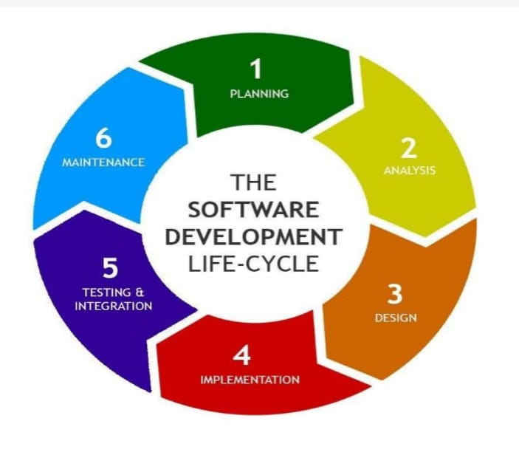

**19) What are the main stages of the software development process?**

**🡪** The main stages of the software development process, also known as the Software Development Life Cycle (SDLC), generally include planning, requirements analysis, design, coding, testing, deployment, and maint**enance.**

**20)** **Write a requirementspecification for a simple library managementsystem.**

**🡪** Requirements analysis is a critical part of the requirements definition and management process in software development. The purpose of requirements analysis is to be sure all product requirements accurately represent stakeholder needs and requirements.

**21)** **Why is the requirement analysis phase critical in software development? Software Analysis.**

**🡪**The Requirement Analysis phase is critical in software development because it lays the foundation for the entire project**.**

1. Clear Understanding of Project Scope

* Defining what the software must achieve ensures developers know exactly what to build.
* Avoids scope creep (uncontrolled changes or continuous growth in project scope).

2. Identifying Stakeholder Needs

* Capturing the expectations of clients, end-users, and project teams ensures the final product aligns with their goals.
* In Agile, this phase involves continuous collaboration to adapt to changing requirements.

3. Improved Planning and Estimation

* Well-defined requirements help in estimating timelines, costs, and resource allocation accurately.
* Reduces the risk of budget overruns.

4. Reducing Rework

* Identifying potential challenges early minimizes future modifications.
* Clear requirements lead to smoother design, coding, and testing stages.

5. Ensuring Functional and Non-Functional Needs Are Met

* Functional requirements describe what the system should do (e.g., login functionality).
* Non-functional requirements focus on how the system performs (e.g., speed, security).

6. Basis for Test Case Development

* Testers use requirement documents to create comprehensive test cases that cover all expected scenarios.

**22) What is the role of software analysis in the development process?**

🡪Requirement Gathering: Collects and documents user needs through meetings, interviews, etc.

Requirement Validation: Ensures requirements are complete, consistent, and feasible.

Defining System Scope: Establishes project boundaries to prevent scope creep.

Creating Documentation: Produces key documents like SRS, Use Cases, and User Stories.

Risk Identification: Detects potential technical challenges early.

Supporting Design & Development: Translates user needs into technical requirements.

Facilitating Communication: Bridges the gap between technical teams and stakeholders.

**23)** **What are the key elements of system design?**

**🡪**Architecture Design: Defines system structure (e.g., client-server, microservices).

Module Design: Divides the system into manageable components.

Data Design: Focuses on database structure, schemas, and data flow.

Interface Design: Covers UI/UX and API integration.

Security Design: Ensures data protection with encryption and authentication.

Performance Design: Optimizes system speed and resource usage.

Error Handling Design: Manages exceptions for smooth recovery.

Scalability & Reliability Design: Ensures system growth and stability under load.

**24) Why is software testing important?**

**🡪**Ensures Quality: Verifies that the software meets functional and non-functional requirements.

Detects Bugs Early: Identifies issues during development, reducing costly fixes later.

Enhances Security: Uncovers vulnerabilities to protect user data and prevent breaches.

Improves Performance: Ensures the software runs efficiently under various conditions.

Boosts User Satisfaction: Provides a smooth and error-free user experience.

Ensures Compatibility: Confirms the software works across different devices, browsers, and platforms.

Validates Functionality: Ensures all features behave as intended.

Reduces Maintenance Costs: Early issue detection minimizes future maintenance expenses.

25) What types of software maintenance are there?

🡪Corrective Maintenance: Fixes bugs and errors.

Adaptive Maintenance: Updates software for changing environments.

Perfective Maintenance: Adds new features or improves performance.

Preventive Maintenance: Enhances code to prevent future issues.

**26) What are the key differences between web and desktop applications?**

**🡪**

|  |  |  |
| --- | --- | --- |
| **Aspect** | **Web Application** | **Desktop Application** |
| Access | Accessed via web browsers (e.g., Chrome). | Installed and run directly on a device. |
| Internet Requirement | Requires an internet connection | Requires an internet connection |
| Installation | No installation needed; accessed via URL. | Requires installation on each device. |
| Updates | Updates are automatic on the server-side. | Users must manually update the software. |
| Performance | Performance may depend on internet speed. | |  | | --- | |  |   Typically faster since it runs locally.   |  | | --- | |  | |

**27)** **What are the advantages of using web applications over desktop applications?**

**🡪** Accessibility: Use from any device with a browser.

No Installation: Access directly via URL.

Automatic Updates: Always up-to-date.

Cross-Platform Support: Works on multiple OS.

Lower Maintenance Cost: Centralized updates reduce effort.

Easy Collaboration: Supports real-time teamwork.

Secure Data Storage: Data stored safely in the cloud.

Scalability: Easily handles growing user demands.

**28) What role does UI/UX design play in application development?**

**🡪** User Engagement: Creates visually appealing and interactive interfaces.

Improved Usability: Ensures intuitive navigation and user-friendly layouts.

Enhanced Accessibility: Designs inclusive experiences for all users.

Customer Satisfaction: Boosts user retention with smooth experiences. Reduced Support Needs: Clear design minimizes user confusion.

Stronger Brand Identity: Consistent design reinforces brand image.

Increased Conversion Rates: Optimizeddesigns guide users toward desired actions.

**29) What are the differences between native and hybrid mobile apps?**

🡪

| **Feature** | **Native Apps** | **Hybrid Apps** |
| --- | --- | --- |
| **Development Speed** | Slow | Fast |
| **Maintenance Cost** | High | Low |
| **Graphical Performance** | Very High | Moderate |
| **Language Used** | Kotlin, Java, Swift | HTML, CSS, JavaScript |
| **Code Portability** | Tough | Easy |

**30) What is the significance of DFDs in system analysis?**

Create a DFD for a hospital management system

🡪Data Flow Diagrams (DFDs) are crucial in system analysis as they visually represent how data moves within a system. They help identify processes, data sources, and storage, making complex systems easier to understand. DFDs aid in detecting inefficiencies and improving system design.

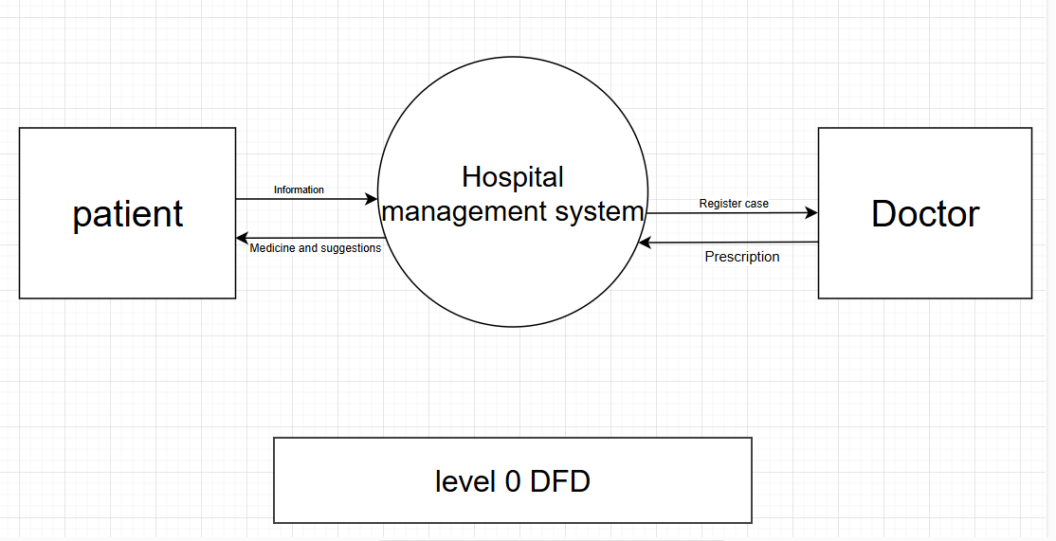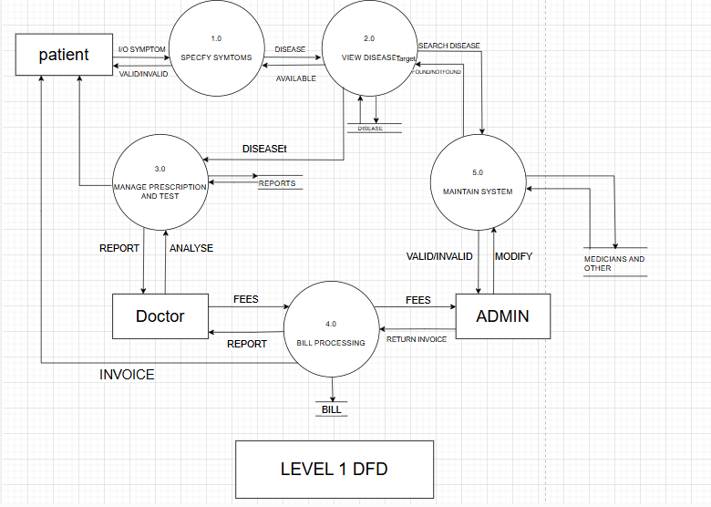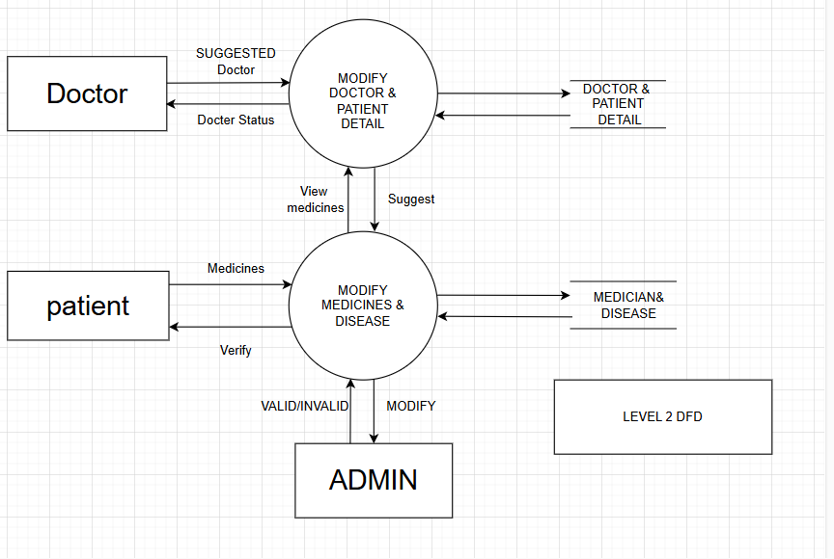

**31)** **What are the pros and cons of desktop applications compared to webapplications?**

**🡪**

|  |  |  |
| --- | --- | --- |
| **Feature** | **Desktop Applications** | **Web Applications** |
| Performance | Faster, uses local resources. | Can be slower due to internet dependency. |
| Access | Works offline. | Requires an internet connection. |
| Security | More secure, as data is stored locally. | |  | | --- | |  |   Data is stored on servers, vulnerable to cyberattacks. |
| Updates | Manual installation required. | |  | | --- | |  |   Automatic updates, no user action needed. |
| Compatibility | OS-dependent (Windows, macOS, etc.). | Works across all operating systems. |

**32)How do flowcharts help in programming and system design?**

**Draw a flowchart representing the logic of a basic online registration system**

**🡪**

1)Visual Clarity – Simplifies complex logic with diagrams.  
2)Problem-Solving – Helps in debugging and identifying errors.  
3)Efficient Planning – Aids in designing algorithms before coding.  
4)Improved Communication – Makes it easier for teams to understand logic.  
5)Standardized Representation – Uses universal symbols for clarity.  
6)Better Documentation – Serves as a reference for future development.

